**<https://techviewleo.com/how-to-install-mysql-on-oracle-linux-server/>**

Install mysql on oracle linux machine/linux/centos

sudo yum update

sudo dnf module list mysql

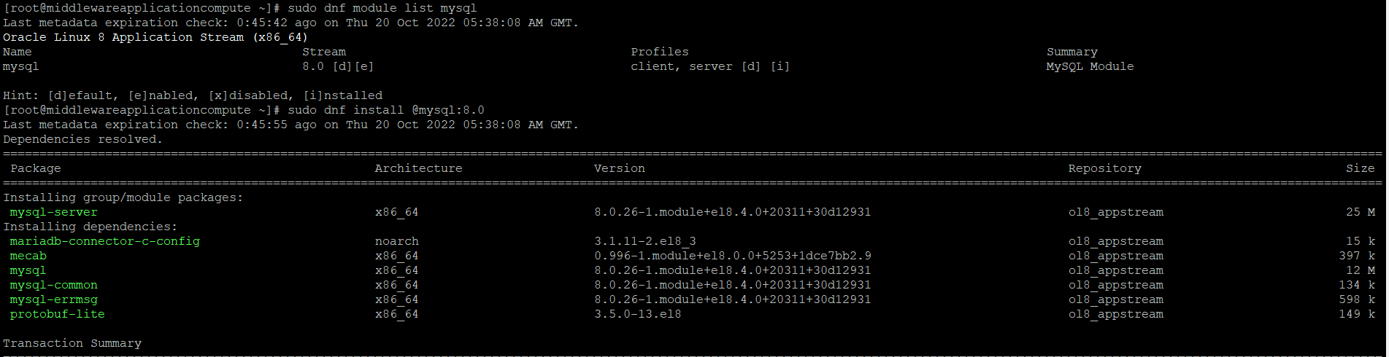

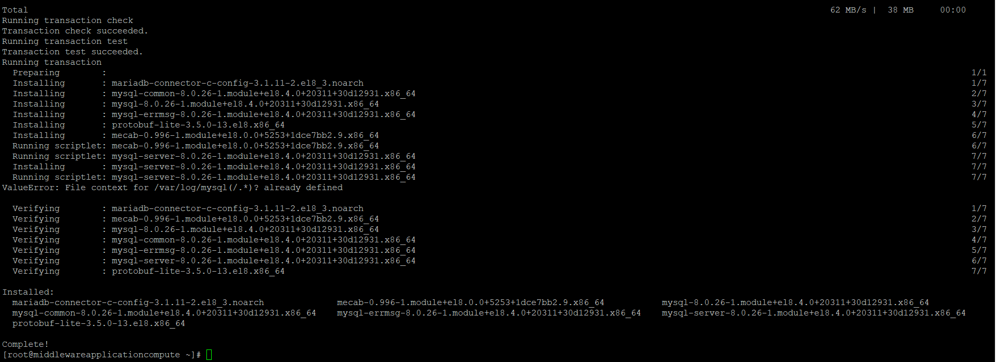

rpm -qi mysql-server

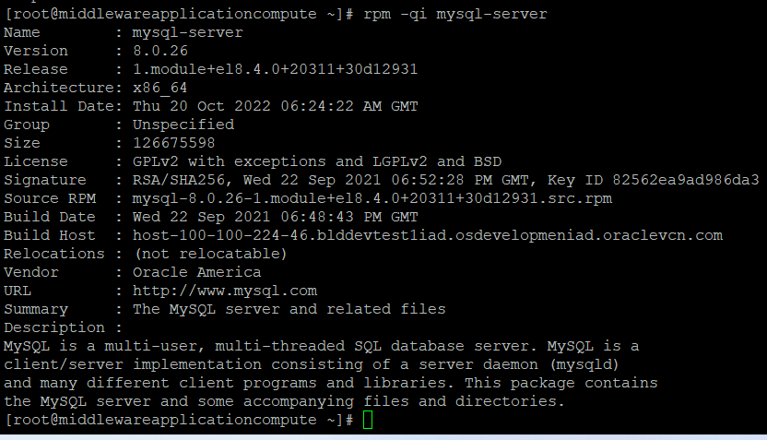

sudo systemctl enable --now mysqld

systemctl status mysqld

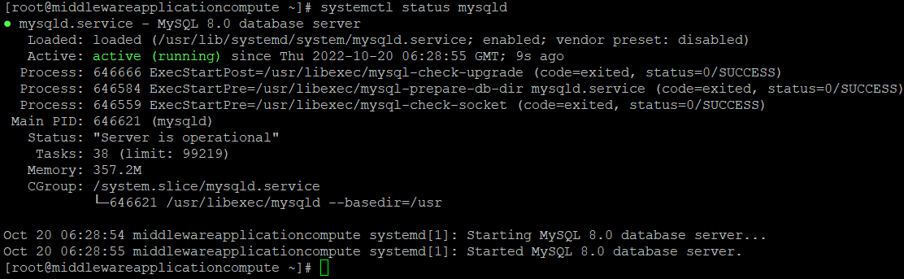

**Open port 7001 ingress rule in oracle cloud using**

sudo firewall-cmd --zone=public --permanent --add-port=7005/tcp sudo firewall-cmd --reload

**Open mysql port 3306 ingress rule in oracle cloud using**

**sudo firewall-cmd --zone=public --permanent --add-port=3306/tcpsudo firewall-cmd –reload**

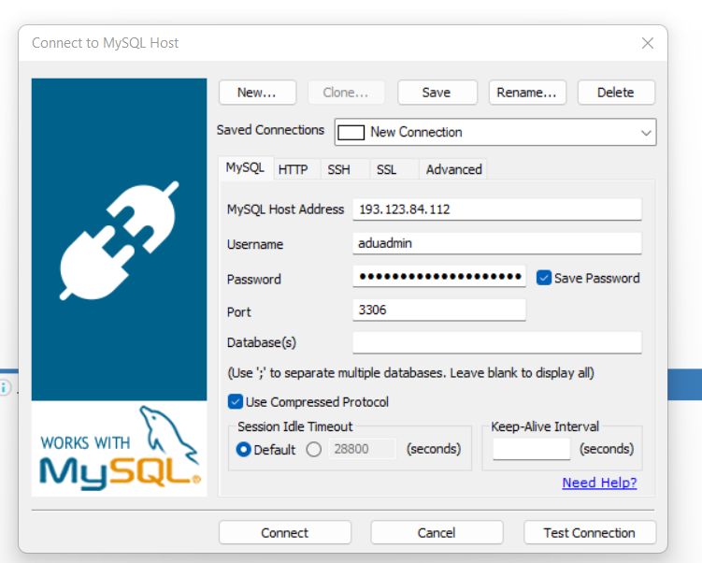

**Now database connection has been established**

